REQUEST FOR MARKETING FIRM PROPOSALS
TO PROMOTE
LARAMIE COUNTY SENIOR SERVICES, INC.
AND THE NEW
LARAMIE COUNTY SENIOR ACTIVITY CENTER
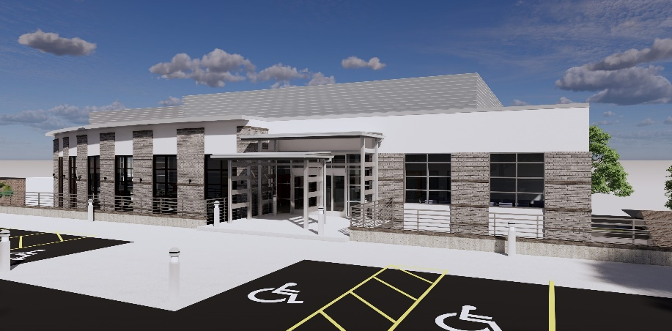
Laramie County Senior
Services, Inc.

Laramie County Senior Services, Inc.
3304 Sheridan Street
Cheyenne, WY 82009

Executive Director, Shanna Harris

January 11, 2024
Table of Contents
OVERVIEW OF LARAMIE COUNTY SENIOR SERVICES, INC. 3
RFP AT A GLANCE 4
STATEMENT OF WORK 5
SUBMISSION REQUIREMENTS 5
EVALUATION FACTORS 5
GENERAL 6
ATTACHMENT I 7
ATTACHMENT II 8
ATTACHMENT III 9

LARAMIE COUNTY SENIOR SERVICES, INC., MARKETING NEEDS:
Laramie County Senior Services, Inc., (LCSS, Inc.) is soliciting Proposals from experienced marketing firms and/or solo practitioners. The successful respondent will provide promotional marketing materials to accomplish the following:
- Create and implement a cohesive marketing campaign.
  - Create a message that promotes interest in the Senior Activity Center (SAC) to all residents of Laramie County (social media, newspaper, direct mail, radio and television).
  - Generate specific messaging for Senior residents of Laramie County that include the value of nutritious meals, the benefits of socialization and the incentives of exercise (direct mail, radio and television, social media).
- Focus/revamp the current website (https://lcseniorservices.com) to more effectively engage the public and communicate organizational activities, including but not limited to:
    - How to support the SAC and make donations.
    - Construction updates on the new Senior Activity Center
    - Highlight services/programs.
    - Introduce the experienced and dedicated board members.
    - More appealing and easier to navigate.
- Effectively inform the public of the operational and governance transition from CHA to LCSS, Inc., in a manner that will generate a willingness to make charitable donations to LCSS, Inc.
- Support the resource development effort, including:
  - Methods to generate an additional $350,000+ each year.
  - Creation of a unified message for board members and the fundraising committee to utilize when soliciting monetary and in-kind donations.
  - Recommendations on donor recognition (plaques, memory wall).
- Help resolve marketing challenges:
- Determine how we serve the same meal to both low income and regular price paying seniors without creating division and apparent discrimination.
- How do we educate the public regarding the governance transition from CHA to LCSS, Inc., that will result in a seamless and understandable transition in the public’s eye?

OVERVIEW OF LARAMIE COUNTY SENIOR SERVICES, INC.
LCSS, Inc., was incorporated as a 501c3 non-profit in August 2022 to govern the Laramie County Senior Activity Center now under construction at 4100 East Pershing in Cheyenne, Wyoming. It has a nine-member Board of Directors, and Executive Director Shanna Harris was hired in September 2023.
Background:
Since 1972, the Senior Activity Center has operated near the library in downtown Cheyenne and has been governed by the Cheyenne Housing Authority, a government agency. While the population of Laramie County has nearly doubled in the last 50 years, the current Senior Center’s capacity has not been able to grow to meet the growing demand; a new Senior Center was needed. In November 2021, with the support of the Laramie County Commissioners, 6th Penny funding for a new Laramie County Senior Activity Center was approved by the voters. Construction of the new Center will be completed in January 2025. Upon construction completion, all services delivered downtown will be relocated to the new Senior Activity Center and LCSS, Inc. will assume governance responsibilities. Services delivered include nutritious meals, Caregiver Program, and various social events/activities. New programs and special event opportunities will be added as LCSS, Inc.’s capacity grows.

LCSS, Inc.’s, mission statement is “Honoring and Preserving Wyoming history and values by enhancing the independence, dignity and self-reliance of all Laramie County senior citizens.”
Its core values are:
Connection
Trust/Mutual Respect
Service
Accountability

RFP AT A GLANCE

Contact person | Shanna Harris  Laramie County Senior Services, Inc.  3304 Sheridan Street  Cheyenne, WY 82009
How to obtain RFP documents | Contact Executive Director, Shanna Harris at:  307-289-8086 or email at sharris@lcseniorservices.com
How to submit a response to this RFP | As instructed in Submission Requirements section. Please submit responses via e-mail, in pdf format to: sharris@lcseniorservices.com
Vendor Response Submittal Deadlines | - Letter of Intent: No later than 12:00 Noon MST, Friday February 2, submit a Letter of Intent to respond to the RFP.  - Complete RFP Response: No later than 12:00 Noon MST, Friday, February 16, 2024
Interview / Demonstration | Finalists will be requested to present a product demonstration on the morning of Thursday, February 22, 2024
Anticipated contract award date | March 4, 2024

STATEMENT OF WORK

The successful respondent must be committed to and demonstrate capacity to perform the following actions between the date of contract award and March 1, 2025.

- Provide evidence of qualifications and experience necessary to promptly and competently meet the above-described marketing needs of LCSS, Inc.

- Become familiar with the demographics of Laramie County.

- Create talking points/marketing messages for use when meeting with groups and prospective donors.

- Create effective appeals that resonate with giving propensity and means of donors and, also citizens who make very few, if any, monetary donations.

- Present the marketing plan to the LCSS, Inc. Board of Directors for consideration/approval.

- Upon approval, implement the plan by creating materials and placing ads in coordination with LCSS, Inc.

- Act as coordinator of public relation opportunities.

SUBMISSION REQUIREMENTS
LCSS, Inc., (Organization) intends to select a marketing firm on a “Best Value” basis, not a “Low Proposal” basis (“Best Value” in that the Organization will consider other factors than cost in making the award decision). Therefore, so the Organization can properly evaluate the offers received, all proposals submitted in response to this RFP must be formatted in accordance with the sequence noted herein:

RFP Section | Description
Attachment I | Submission Cover: This form is attached as Attachment I to this RFP. This form must be fully completed, executed where provided thereon and submitted under this section as a part of the response.
Attachment II | Evidence of Ability to Perform Statement of Work: Provide thorough responses to all information requested.
Attachment III | Letter of Interest and Pricing Proposal: Provide thorough responses to all information requested.

EVALUATION FACTORS
Selection of a successful respondent will be the sole discretion of the Organization. An Organization evaluation committee will be established to review Offeror responses to this RFP. Proposals will be evaluated using the following evaluation criteria. Offerors will be selected based on the highest cumulative score, as provided below. The Organization, however, reserves the right to reject any and all proposals and to waive any informality in proposals received for any reason whatsoever.

Evaluation Criteria | Maximum Points
Proposed Cost | 25
Capability to promptly provide professional marketing services from date of award through March 2025. | 40
Relevant experience marketing similar projects. | 35
Total Points | 100

GENERAL
All proposals and material contained therein shall become the property of LCSS, Inc., upon submittal.
Regardless of outcome, Respondent shall not hold LCSS, Inc., responsible for any expense in the preparation of its response to this RFP or in negotiating a contract with LCSS, Inc.
The determination of the criteria and process whereby proposals are evaluated, and the decision as to a contract award, or whether or not an award shall be made as a result of the RFP, shall be at the sole discretion of LCSS, Inc., and its Board of Directors.

ATTACHMENT I
Submission Cover

Instructions: The items listed below must be completed and included in the proposal submittal. Please complete this form by making an “X,” where provided (“Item Included” column), to verify that the referenced completed form or information has been included with the hard copy submittal. Complete the Primary Point of Contact and Respondent’s Statement as noted below:

Item Included  (Check Box) | Submitted Items
 | Attachment I - Submission Cover
 | Attachment II – Evidence of Ability to Perform Statement of Work
 | Attachment III – Letter of Interest and Pricing Proposal

Primary Point of Contact

Name Phone Number E-mail Address

Respondent’s Statement

The undersigned respondent hereby states that by completing and submitting this Form and all other documents within this proposal submittal, he/she is verifying that all information provided herein is, to the best of his/her knowledge, true and accurate, and that if LCSS, Inc., discovers any information entered herein to be false, such shall entitle LCSS, Inc., to cancel any award with the undersigned party. Further, by completing and submitting the proposal, the undersigned is hereby agreeing to abide by all terms and conditions pertaining to this RFP as issued by LCSS, Inc.

Signature Date Printed Name Company

ATTACHMENT II
Evidence of Ability to Perform Statement of Work

Please provide the following:

- Company Profile:
Provide a summary specifically related to:
- development and implementation of successful marketing campaigns
- location of company offices

- Previous experience:
Experience performing the Statement of Work, and qualifications of Respondent’s staff assigned to this project, including firm’s ability to meet the requirements listed in the Scope of Work

- Customer References
Provide a list of at least three (3) current or previous customers. For each reference, provide the following information:
- Name of customer
- Contact person’s name and position
- Telephone number
- Email address

- Sample Marketing Materials
Provide examples of marketing materials created for use in previous or current marketing campaigns.

- Interview / Demonstration:
Confirm availability for a potential verbal interview, on-line product demonstration, or an on-site product demonstration on February 22, 2024.

ATTACHMENT III
Letter of interest and Pricing Proposal

Please provide the following:

- Letter of Interest
Describe any special interest your firm may have in engaging in marketing for a new Laramie County Senior Activity Center between date of award and March 31, 2025.

- Pricing Proposal
Note that LCSS, Inc. has budgeted $50,000 for marketing. List your pricing proposal to perform your proposed marketing activities.

